Technical Design Report: Smart-Meter Data Pipeline
Prepared by: ENG\ Hend Mahmoud
Project: GreenStream Energy "Dark Data" Transformation

Task A: ETL Architecture Diagram
The goal of this design is to move data from smart meters to a place where we can easily analyze it. We use a "Serverless" approach, which means the system only works when new data arrives to save costs.

Workflow Steps:
- Source: Raw electricity data (CSV files) sent by 50,000 smart meters.
- Raw Storage: The first "landing zone." We keep the original files here in case we need to re-check the data later.
- Transformation Layer: This is the cleaning stage. It automatically starts whenever a new file is uploaded.
- Destinations:
  - Structured DB (SQL): For daily reports and quick checks on current energy use.
  - Analytical Archive (Parquet): For long-term research. We use Parquet because it is a compressed format that makes searching through millions of rows much faster for AI models.
- Orchestration (Success/Failure):
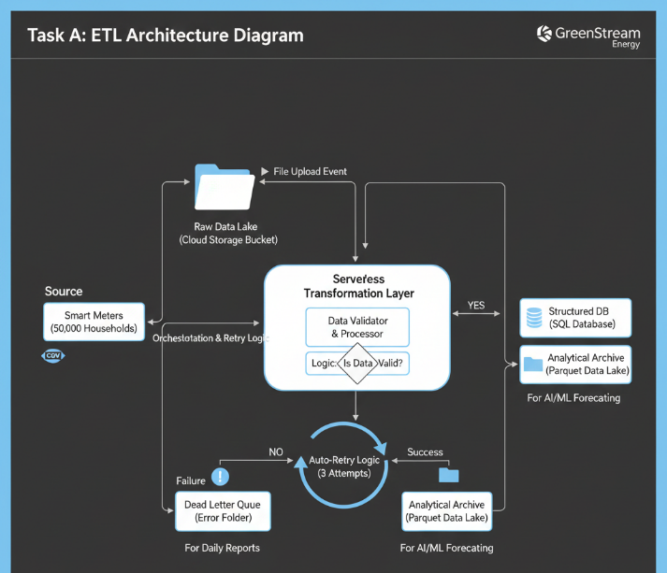
  - Success Path: Data is saved, and a "Success" log is created.
  - Failure Path: If the system crashes, it retries 3 times. If it still fails, the data goes to a "Dead Letter Queue" (Error Folder) for us to fix manually.

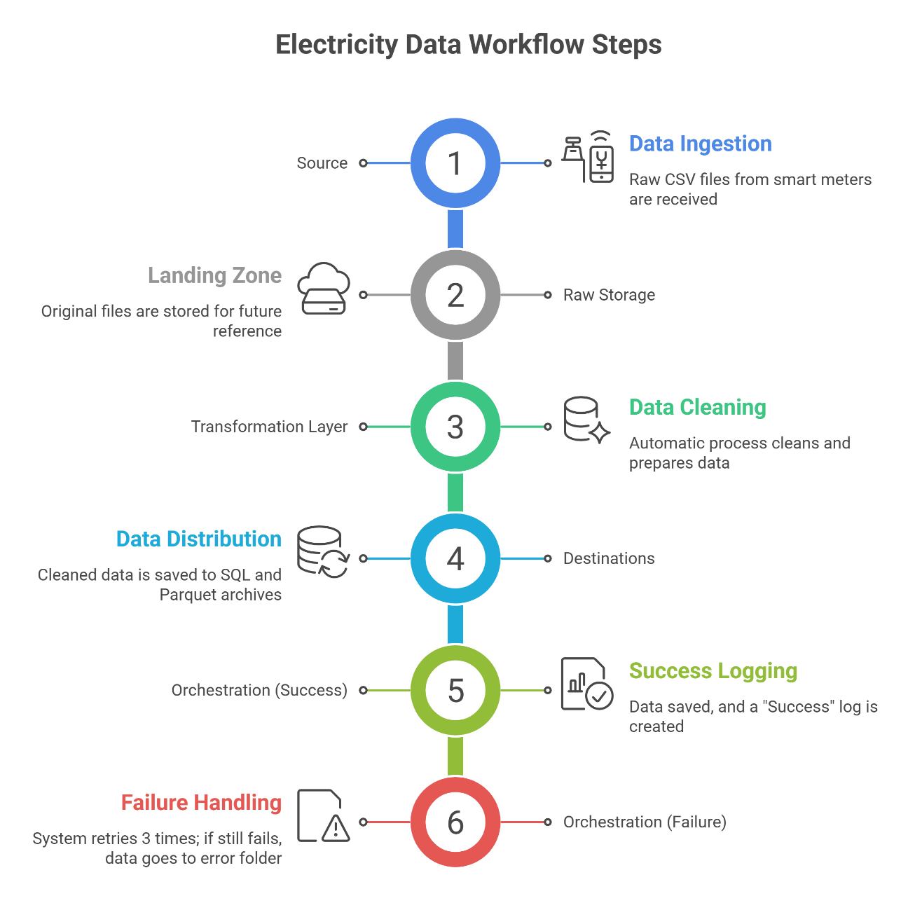

Task B: Transformation Logic & Business Rules
In the "Transform" phase, we apply these rules to make sure our data is accurate:
- Rule 1: Unit Standardization
  - Logic: If the unit is "W" (Watts), divide the value by 1000 to change it to "kW" (Kilowatts).
  - Reason: We need all data in the same unit so we can add them together correctly.
- Rule 2: Handling Missing Values
  - Logic: If a reading is NULL (empty), we use the average of the readings before and after it (Interpolation). If a lot of data is missing, we flag it as "Gap" and don't use it for calculating peaks.
- Rule 3: Data Validation
  - Logic: If a reading is negative (less than 0) or impossibly high (e.g., > 50kW for a small house), mark it as an "Error" and ignore it.
- Rule 4: Faulty Meter Detection
  - Logic: If a meter reports exactly "0.00" for 24 hours straight during a cold or hot day, flag it as a "Potential Faulty Meter" for inspection.

Task C: Single Record Lifecycle Explanation
Let’s follow one specific reading (e.g., Meter #123, 10:00 AM, 3000 Watts) through the system:
- Upload: Meter #123 sends a CSV file to Raw Storage.
- Trigger: The system "sees" the new file and immediately starts with the cleaning code.
- Cleaning & Validation: The system sees "3000 Watts" and converts it to 3.0 kW.
  - It checks the number: "3.0" is a normal, healthy reading.
- Storage (SQL): The clean 3.0 kW reading is saved in a table so the company can see the 10:00 AM energy demand right away.
- Archiving (Parquet): To save space, the record is converted into a Parquet file. This format is perfect for when we want to train a "Future Forecasting" model next month.
- Success or Failure: If the database is busy, the Orchestrator tells the system to wait and try again.
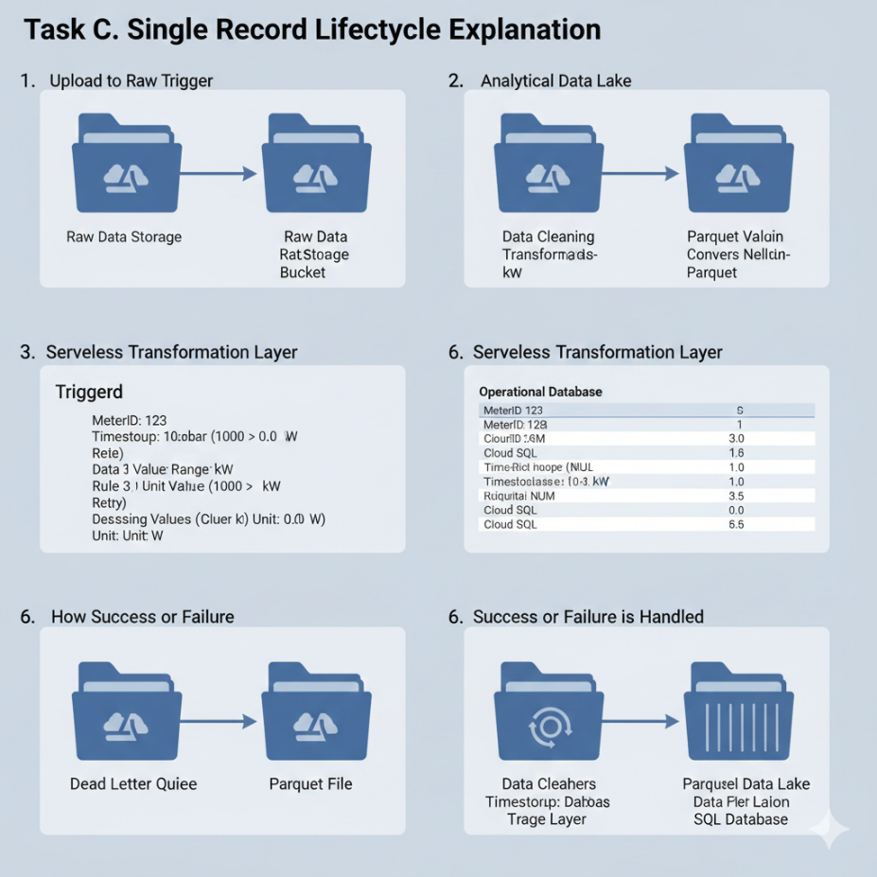
  - Once the data is safely stored in both places, the process is complete.

